2400040454
Harsha Vardhan.

AIM: Learn LaTeX in 30 minutes.
Outcomes: Students are able to understand visualization importance and create simple Resume.
Apparatus/Software required: over leaf or latex, System/laptop with minimum specifications.
Procedure:
1.open google in your laptop.
2.after opening laptop type the “over leaf editior”.
3.click on first opened link.
4.after opening it you will get different types ofof documents to create the project click on new project
5.after opening it click on template and select “CV and resume”.
6.Create your own resume .
7.

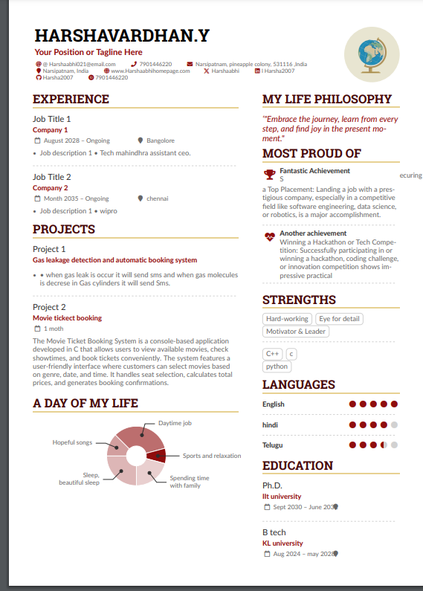

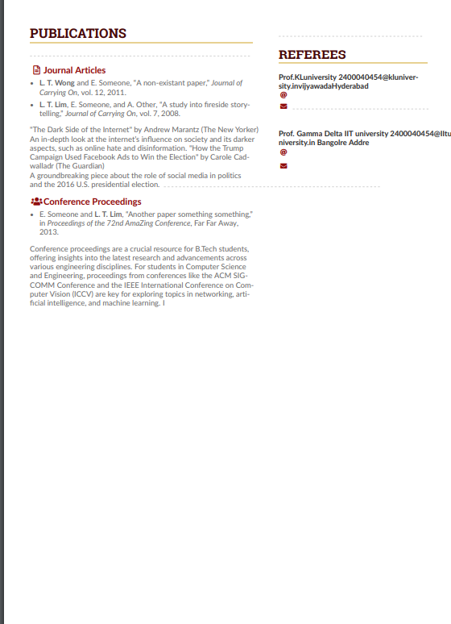

Result: completed your resume.

